13016235: C Programming
First Semester, 2017

Project Proposal

- Project developer
Student ID | Name
59090007 | Krit Tangcharoenkijkul

- Project title
Melody (Music Note Game)

- Project description and requirements
Project description:

Melody is a musical game where the goal is for the user to try to beat the high-score of all song inside the game. Player must press the button on the keyboard that is synchronized with the note on the screen. The main control button of the game required only three button which are F key, J key and Space key on the keyboard. G and H key is other key used in this game. This game use raylib.h library for Graphical User Interface and creation of this game. There are 2 songs available for player to choose from which are 1st Only My Railgun by FripSide and 2nd My Mai Tonight by Aqours. Both song is covered by Silverick (violinist). Player will be directed to the gaming screen after selection of music. As the note fell, player must have pressed the key on the keyboard corresponding when the note hit the base. Point will be added up for each key pressed while consecutive combo will allow user to gain more point by connecting notes in a row. The game will end when the music has ended, player will be given cleared statue and summary screen will be shown. Results will be announced, and player will be given option to go back to main menu to play again or quit the program. Raylib library is crucial in creating shape, importing music and sound into the game. Text and score is updated frame by frame while the song is also counted per every frame. This game ran on 60 frames rate per second and RGB color for graphical user interface.

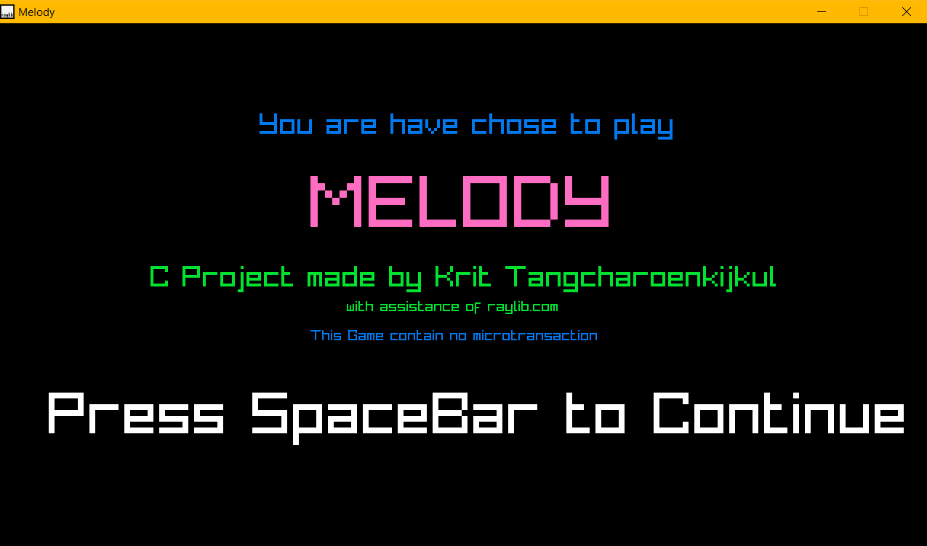
Introduction Screen

Introduction Screen is the first screen that appear to the user. The screen displays the name of the game (Melody) and basic information about this game such as the creator of this game and library used. Pressing Spacebar will continue the game to the main menu screen.
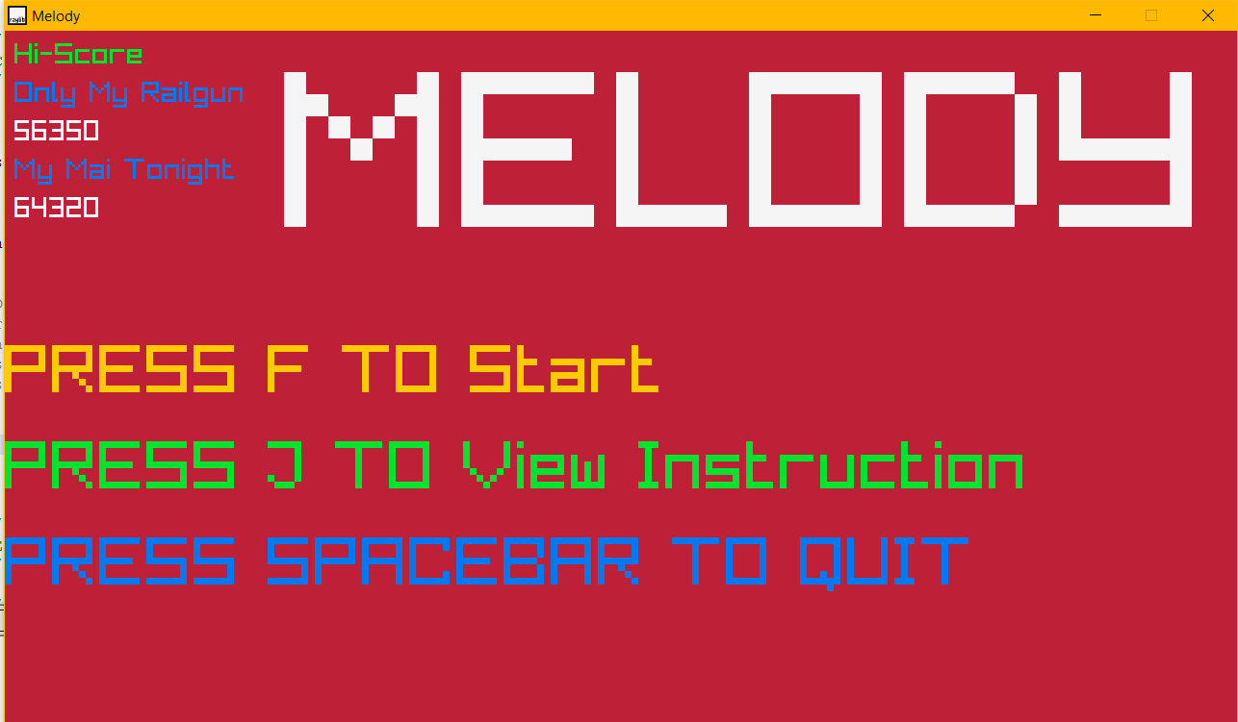
Main Menu Screen

In the main menu screen, the hi-score of both song is import into the program. Only My Railgun and My Mai Tonight. Main Menu song is playing in the background currently. Pressing G will restart the main menu music while Pressing H will pause the music. Melody title is displayed hugely on the main menu will 3 further direction for user to follow. F will go to Song Selection Screen. J will show instruction of this game. Spacebar will close window and program immediately

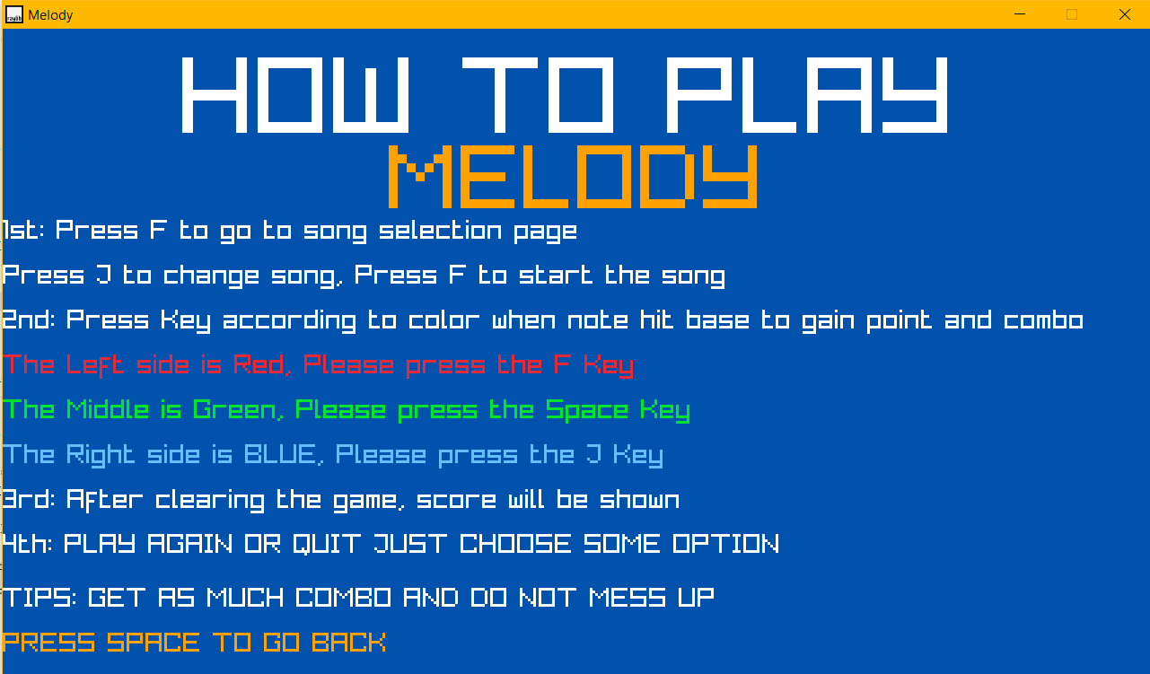
Instruction Screen / How to play

This screen will allow user to understand what is required from them to play this game. Music will also be played in background. Spacebar will go back to the main menu.
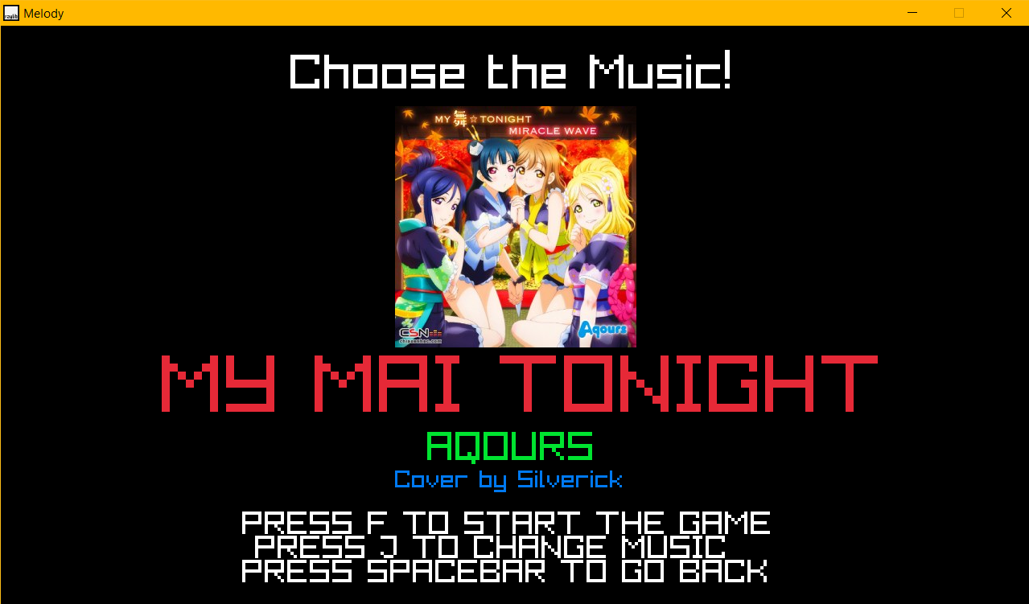
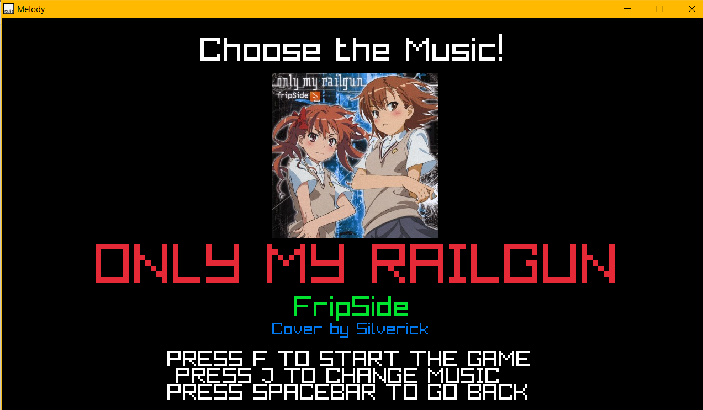
Choose Song / Start Screen

After pressing F on the main menu screen. Player will be direct to the screen on the left. Pressing F will start the game while pressing J will direct to screen on the right for another song. Pressing Spacebar on either screen will direct user back to the main menu. Different song has different music and different note pattern along with it. Music sample will be player to listen for their desire music
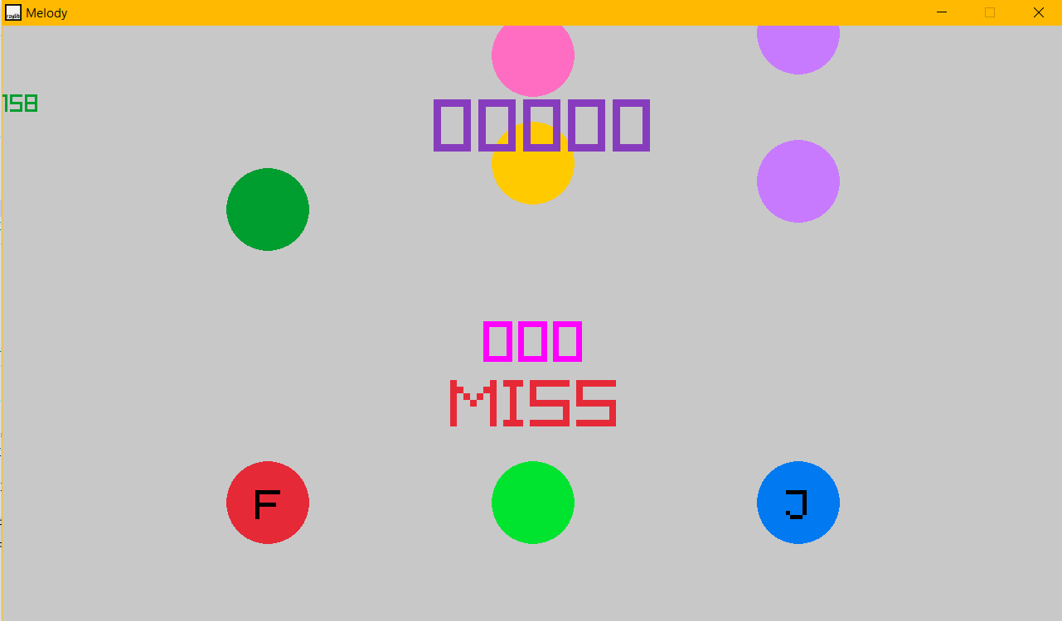
Initial Screen

Either of the song will direct user to the initial screen. Music will start to play. And note will begin to fell down to the base (Red, Green, Blue button). Purple digit on top display the amount of point player got. Pink is for Combo while next will display what happen on the last note whether player miss the note (MISS) or hit the note (PERFECT).
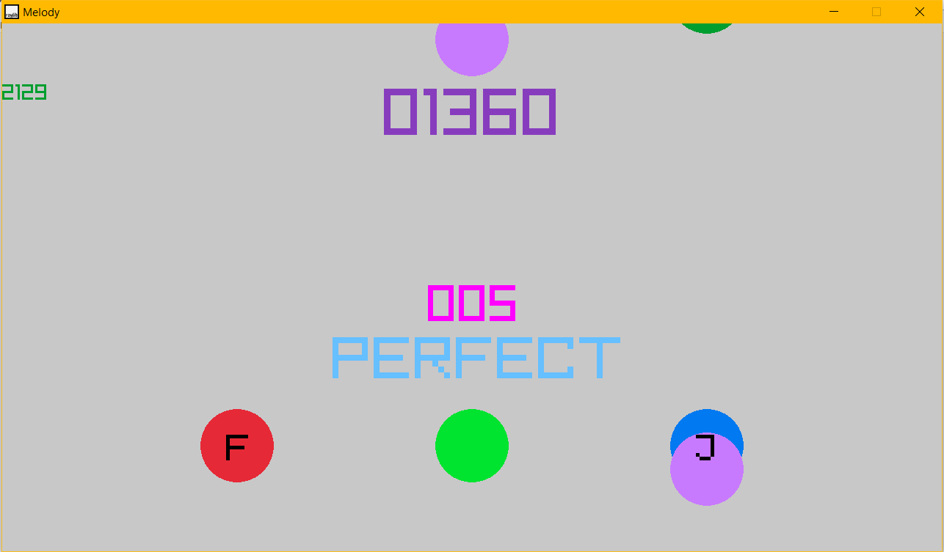
Game Screen

Throughout the game the note will be falling in different pattern according to different song. If player hit note correctly, point will be added while combo will increase more point pressed per single note (1st = score + 100, 2nd = score + 110, 3rd = score + 120 and so on). However, if player pressed the key when there are no note or player allow the note to fell off the screen, combo will be reset to zero and start again. Green digit on the left display the frame that is currently in. Player can view to prepare for transition. This is going to continue until the music is finished. Player cleared the game when music is finished, they will be transit to the summary screen.
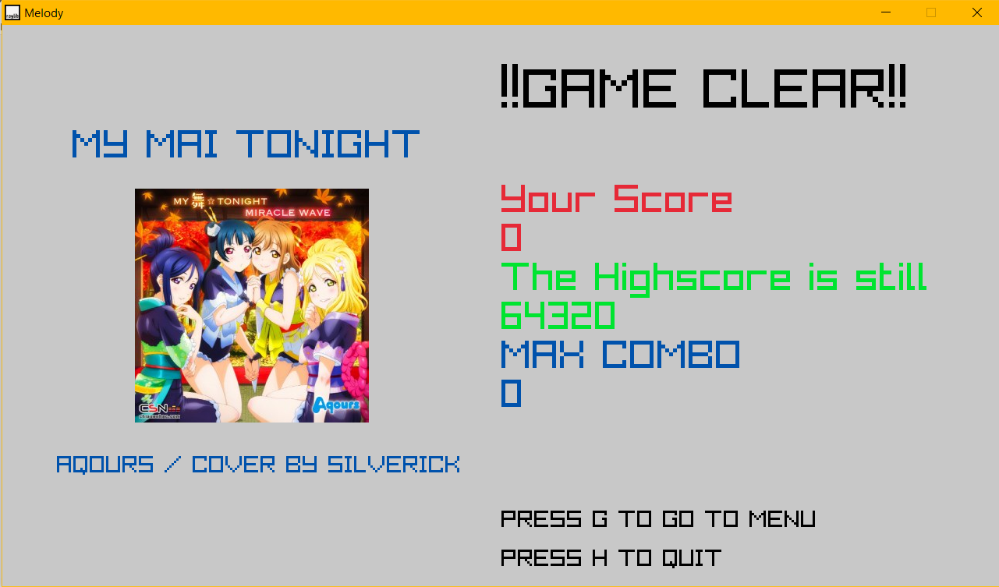
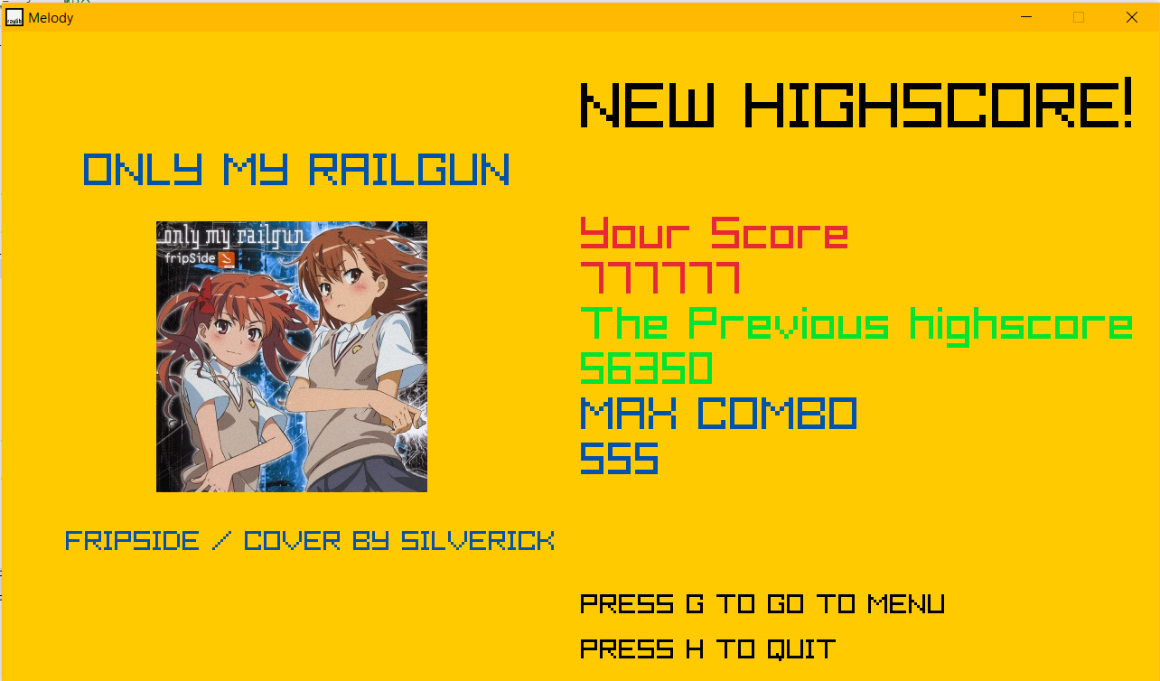
Summary Screen

After the game is cleared, player will be directed to the summary screen. There are two different condition for different scenario. If the player managed to be the previous high score, summary screen will display the screen similar to the one on the left while will alert user that they manage to beat the previous high-score, otherwise, the screen on the right will be shown to show user that they have managed to successfully cleared the game. Either option will displayed user score, previous high-score or current high-score depending on different case. The amount of maximum combo player managed to get will also be displayed along with the song name and album cover. Pressing G will save the high-score, reset the game and go back to the menu while pressing H button will save the high-score, reset the game, remove other variable and exit the game.

